A Search for Gravitational Waves with VIRGO

General Relativity (GR) is one of the most fundamental and beautiful physical theories. Yet it is poorly tested, as compared to other fundamental physical theories (e.g., quantum electrodynamics). One of the key features of GR is the dynamical nature of space-time itself: its curvature is a time-dependent quantity, and ripples of curvature can propagate through space-time with the speed of light. Such propagating curvature-ripples are called gravitational waves (GW), and their existence is one of the most important, yet untested, predictions of GR. In our universe, GW are produced by unique astronomical events, such as mergers of pairs of black holes or neutron stars, and supernovae explosions. GW can be used to probe the evolution of such compact objects. Such data are entirely independent of any observation in the electromagnetic spectrum, and are therefore likely to lead to unique information on such compact objects. Moreover, GW propagate almost unperturbed through essentially the entire universe. This makes it in principle possible to detect GW-signals emitted essentially during the Big-Bang. Measuring the amplitude at different frequencies should give information on matter at energies around 10¹⁸ GeV, a scale that will never be reached by men.
As the spectrum and amplitude of GW sensitively depends on the details of the Big Bang models, i.e. inflationary fields causing rapid expansion of the universe' size, rapid collapse of cosmic strings, etc., such data will represent the first direct test of such models. Thus, detection and further observation of the GW would both provide important tests of GR and would open a new window for astronomical observations of fascinating cosmic phenomena.

GW-signals, however, are expected to be extremely weak (causing relative displacement of free masses by distances which are a tiny fraction of the size of an atomic nucleus), and thus enormous technological challenges have to be overcome in order to make a detection. Large resources all over the world have been committed to building several types of gravitational-wave observatories.
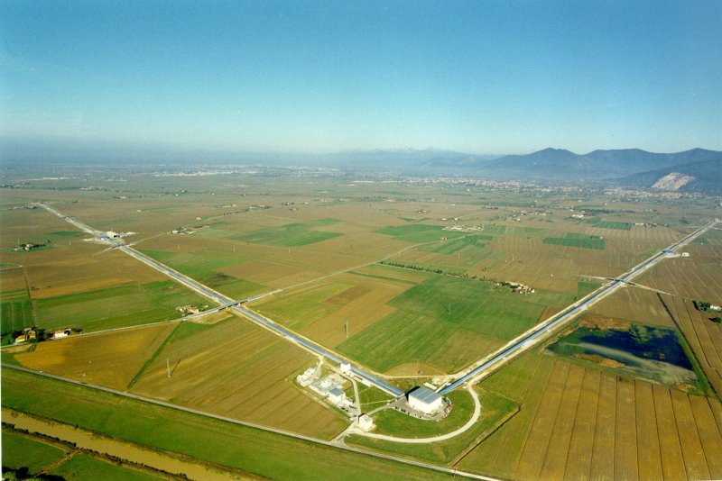

Fig.1. The Virgo interferometer near Pisa, Italy, consists of two 3 km long arms.

NIKHEF has joined VIRGO, a Michelson type interferometer (ITF) with a base length of 3 km. It has been built by a French-Italian collaboration at Cascina close to Pisa and is poised to take data later this year. Fig. 1 shows the ITF, where a laser pulse is split and travels a number of times up and down each arm after which it creates an interference pattern with the other pulse. A change in the path length due to a passing gravitational wave can be deduced from a change in the interference pattern. NIKHEF contributes to the alignment and thermal stabilization of the ITF. In addition, NIKHEF searches for signals from (binary) pulsars.

Gravitational wave astronomy will be further developed by the satellite-based interferometer project, LISA,. It will have three satellites positioned in orbit around the sun, trailing the Earth by some 20 degrees. The range of sensitivity of LISA is expected to reach down to 10⁻⁴ Hz. This will enable e.g. the observation of the coalescence of massive black holes.

