Registration form (basic details)

1a. Details of applicant
-Name, title(s): M. Mevius, Dr.
-Male/female: female
-Address for correspondence:
M.Mevius
Kapteyn Institute
P.O. Box 800
9700 AV Groningen
the Netherlands
-Preference for correspondence in English: no
-Telephone: +31 (0)50-5634089
+31(0)6-49664159
-Fax: : +31 (0)50-3636100
-E-mail: mevius@astro.rug.nl
-Doctorate: 02/04/03
-Use of extension clause: no

1b. Title of research proposal
Gravitational Waves from Spinning Neutron Stars

1c. Summary of research proposal

Gravitational waves (GW), a fundamental consequence of General Relativity, have not yet been observed directly. Their signals are very weak and only extreme extra-terrestrial events can be the source of detectable GW’s. Current laser interferometers are reaching sensitivities which makes a direct detection of GW’s in the near future probable. Sources of GW’s that are detectable on Earth, are Supernova (SN) explosions and mergers of heavy objects in nearby galaxies, and fast spinning neutron stars (NS) in our Galaxy. I aim at using the data of the Virgo Michelson interferometer to establish a signal of GW’s from spinning NS’s, specifically NS’s that are accompanied by another star (binary systems).

NS’s, remnants of SN explosions, are tremendously compact objects that rotate with high frequencies. In contrast to SN and merger events, the GW signal from NS’s is continuous, which makes it possible to integrate over long times and, very importantly, to confirm a detection. The expected number of NS’s in our Galaxy is 10⁹, but most of the known NS’s (observed on Earth as pulsars) have too low rotational frequencies to emit GW’s with frequencies inside the Virgo sensitivity band. NS’s in binary systems are especially interesting sources, since they tend to have higher rotational frequencies and the emission of GW’s from such systems might be stronger than that of isolated NS’s.

The number of observed pulsars is ~10⁶ times lower than the total number of NS’s in our Galaxy. An “all-sky” search for a signal from unknown NS’s involves exploring a huge parameter space, even larger if the search is to include binary systems. This is a enormous computational challenge. The proposed research will mainly concentrate on the development of algorithms which are sensitive for the very weak signal and capable to perform this task with realistically available computing power.

keywords: Gravitational Waves, Neutron Stars, Pulsars, Virgo, Michelson interferometer

1d. Former Vidi applications
None

1e. NWO Council area
N

1f. Host institution (if known)
VU/Nikhef

Research proposal

2. Description of the proposed research
word count: 3802

2a. Research topic

2a.1 Introduction

Of the four fundamental forces of nature, gravity is the least known, although we experience the effects of gravity everyday. In the macroscopic world gravity is the dominating force due to its long range of interaction and the fact that there is no shielding such as, e.g., in the case of the electro-magnetic interaction. On atomic scales its effects are negligible. Only at extremely small distances gravity again becomes the all-determining force. Ultimately, gravity is responsible for the evolution of the Universe, of the galaxies, and of the formation of Neutron Stars and Black Holes. A quantum field theory describes a force through the exchange of a specific particle, the so-called gauge boson. For the electro-magnetic, weak and strong interactions these bosons have been experimentally well confirmed (the photon, W and Z bosons and the gluons, respectively). The exchange boson of gravity, dubbed graviton, has not yet been observed. The same is true for Gravitational Waves (GW), which can be viewed consisting of coherent states of many gravitons, although indirect evidence for their existence is available. Very sensitive detectors are needed and only extreme events can be the source for detectable GW’s. The expected sensitivity of the current generation of interferometers for GW’s detection is such that a detection of GW’s from sources in our galaxy and in nearby galaxies in the near future is very probable.

The existence of GW’s follows from Einstein’s theory on General Relativity (GR). Hulse and Taylor [1] measured the energy loss of a strongly eccentric binary pulsar system to be in agreement with the predictions of Einstein’s theory. This is taken as an indirect proof of the existence of GW’s, which was honoured by a Nobel prize in 1993. In 1959 Weber suggested [2] that GW’s from strong sources in the Universe could be directly detected with resonant detectors and he built the first resonant bar detector in 1960. Since then the detection techniques have improved radically and although today resonant bar detectors are still in operation, laser interferometers offer by far the best sensitivity and the largest frequency range.

The most sensitive interferometer experiments at present are LIGO and Virgo. LIGO is already taking data and first results (upper limits) have been published. Virgo is finishing its commissioning phase and prepares a 1-year science run in 2007. I propose here to use the Virgo data for the detection of GW’s from fast rotating Neutron Stars (NS). Since a fully coherent all-sky search for GW’s from spinning NS’s exceeds the world-wide available computing power by ~15 orders of magnitude, the main research proposed here concentrates on advanced computing techniques, i.e. developing better algorithms to filter the tiny signal with realistically available computing power.

The first direct detection of GW’s will be a major discovery, and this is in itself is a compelling reason to be involved in this research today. Once GW’s are established, they can be used as a novel probe to study the Universe. Since the interaction of GW’s is so weak, they are not scattered like photons, and carry information on the process in which they originated, over much longer times. In contrast to electro-magnetic radiation the early Universe is transparent for GW’s, such that we can observe GW’s from processes shortly after the Big Bang. It has been speculated that the nature of dark energy and matter can only be uncovered via its gravity interaction.
I believe that the extreme conditions in the Universe, that cannot be reproduced at laboratories on Earth, provide an excellent source of information for the physics involved in such circumstances, and must therefore be fully exploited.

Where these aspects lie outside the scope of current Earth-based detectors, the space-based project LISA (foreseen launch date 2017) is designed to study the Universe using GW’s. Although LISA will be sensitive at different frequencies than Virgo and LIGO, the detector principle is the same. A firm detection of GW’s and further investigation by Earth-based detectors will contribute to the success of LISA, and LISA will profit from the data analysis techniques developed for LIGO and Virgo.

2a.2 Theory

The basic equation of GR:

$G_{\text{αβ}}=8{πT}_{\text{αβ}}$ 2a.2 1

states that spacetime curvature (G) is related to the energy mass distribution (T). It actually yields 10 independent equations, known as the Einstein Field Equations, of which the solutions are metrics (or structure) of spacetime. GW’s, time dependent deformations of spacetime travelling at the speed of light, are a fundamental consequence of GR.

At long distances from the source, GW’s are nearly plane waves and can be defined in a linear approximation as a small perturbation (h_{μν}) of the metric (n_{μν}):

$g_{\text{μν}}=n_{\text{μν}}+h_{\text{μν}}$ $(\left|h_{\text{μν}}\right|\text{<<}1)$ 2a.2 2

With a specific choice of coordinates (the “transverse-traceless” gauge), a GW propagating in the z-direction can be written as:

$h_{\text{μν}}=\left(\begin{matrix}0 & 0 & 0 & 0 \\ 0 & h_{+} & h_{x} & 0 \\ 0 & h_{x} & −h_{+} & 0 \\ 0 & 0 & 0 & 0\end{matrix}\right)$, 2a.2 3

with h₊ and h_{x} the two different polarizations of the wave. The effect of a GW is a time dependent variation (δ) of the distance () between two freely falling test masses. Since the polarization of the wave is such that a change of δ in the x-direction corresponds to a change of -δ in the y-direction, it can be monitored with an interferometer with two perpendicular arms. The strain of the wave is the relative change in distance:

$h(t)=\frac{δℓ}{ℓ}$ 2a.2 4

The emission of GW’s can be described as:

$h_{\text{jk}}=\frac{2G}{c^{4}}\frac{1}{r}{\overset{¨}{Q}}_{\text{jk}}$, 2a.2 5

with c the speed of light, G Newton’s gravitational constant, r the distance to the source and Q the quadrupole moment of the source. The dots indicate the second time derivative. The source of a GW must be an accelerating mass-quadrupole-moment.

2a.3 Detector

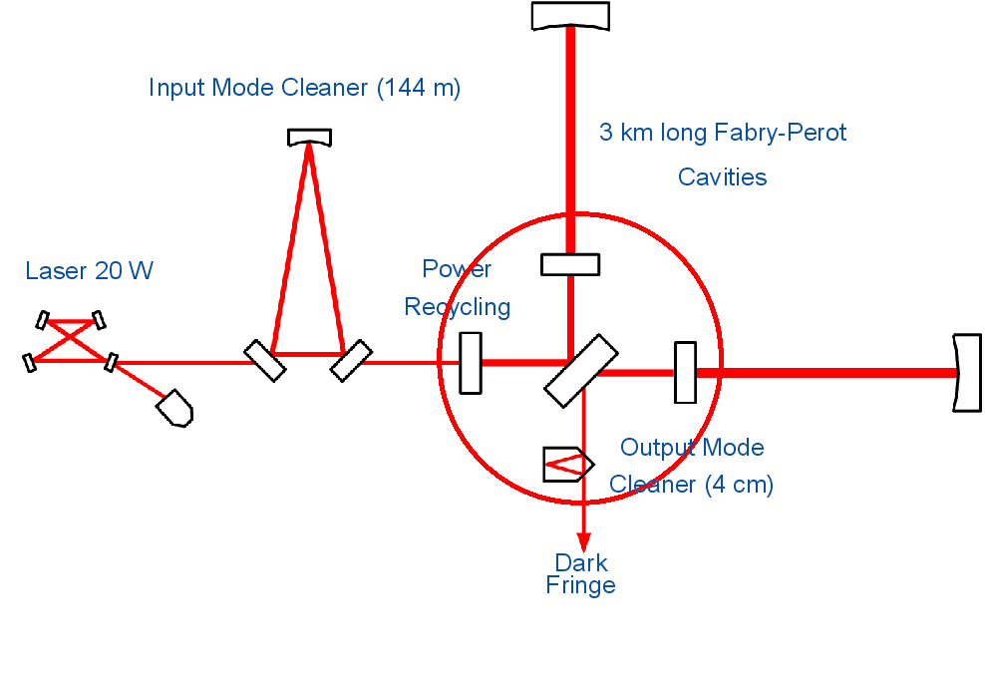
Virgo is a Michelson interferometer located near Pisa. A schematic drawing of Virgo is shown in Figure 2a.3 1. A laser beam is split into two perpendicular beams, which are reflected on mirrors at the end of 3 km long arms. At the output the two beams are combined and tuned to form a dark fringe. A change in relative arm length results in a phase difference between the two beams and will lead to a change of the interference pattern. The signal consists of the number of photons at the output. Inside the two arms Fabry-Perot cavities effectively increase the arm length to 120 km and also filter the wavelength of the laser beam. The power recycling mirror, which recycles the light that would otherwise be lost, increases the power in the cavities.

Figure 2a.3 2 shows the design sensitivity of Virgo and the various noise sources. At low GW frequencies seismic noise dominates. The mirror suspension of Virgo, consisting of super attenuators and inverted pendulums, is designed to isolate the mirrors from seismic noise by at least a factor of 10⁹. At high frequencies the noise is dominated by statistical fluctuations in the number of photons (shot noise). The optimal frequency is around 200 Hz, where a sensitivity between 10⁻²² and 10⁻²³ √Hz can be reached.
Fig. 2a.3 1 Schematic layout of the Virgo detector

The LIGO experiment in the United States consists of one 2 km and two 4 km interferometers, similar to that of Virgo. Close cooperation between these experiments is considered to be crucial: the “false alarm” rate can be suppressed significantly by coincident methods between two independent detectors. Furthermore, close coordination allows to have at least one (if not more) detectors running at any given moment in order to record possible signals of a close merger or supernova explosion. And finally, the huge data analysis effort can profit from a combined investigation of possible algorithms. As a benefit, a Memorandum of Understanding between LIGO and Virgo (in preparation) will allow the members of the two collaborations to use each others data. Virgo planned the start of the first 1-year science run in the spring of 2007 to overlap with data taking of LIGO. A second science run with an upgraded detector is planned for 2009.
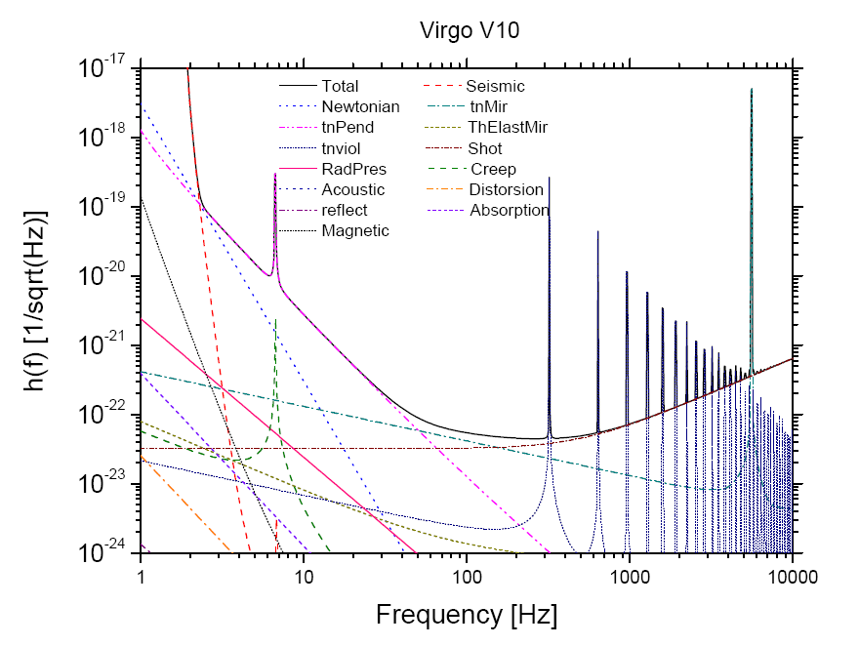
2a.4 Sources

Possible sources which are detectable with the Virgo detector are supernova events (SN), mergers of massive objects (black holes or NS’s) and fast spinning massive objects [3]. The former two represent events which happen with an uncertain rate, perhaps once a year. Moreover, a detection of a signal from such events needs to be confirmed with a coincident detection, either of the GW by another detector, or of the event through different radiation.
Fig. 2a.3 2 Design sensitivity of Virgo. The coloured lines show the different noise contributions.

The latter class form the “periodic sources”, fast spinning NS’s with an intrinsic quadrupole moment. Compared to a SN or a merger, the signal from a NS is several orders of magnitude weaker. However, the source is continuous such that the signal can be integrated over a long time. A NS can be “close” - at a distance of kpc as compared to Mpc for mergers and SN’s and many such sources must exist in our galaxy. Finally, since the source is constant, a detection of GW’s from the source can be confirmed. These are the main reasons why I believe that NS’s are the most promising sources for GW detection.

2a.5 GW’s from NS’s

NS’s are remnants of supernova explosions. They are exceptionally compact objects, their masses are about 1.5 solar masses squeezed into a sphere with a radius of about 10 km. If their strong magnetic fields are oriented differently from their rotational axes a cone of electro-magnetic radiation is emitted at the magnetic poles that can be observed as a short flash every time it passes the earth. Such NS’s are called pulsars.

Pulsars can be accompanied by another star, to form so called binary systems. At present, about 1600 pulsars are known [4]. From the average rate of supernova explosions one estimates about 10⁹ NS’s in our galaxy. The rotation frequency of a pulsar usually decreases slowly in time. This spin-down is caused by energy loss of the system, presumably, amongst others, due to the emission of GW’s. In figure 3 the rotation frequency versus the spin-down is plotted for most known sources. Pulsars in binary systems tend to have a higher frequency and lower spin-down. This is possibly due to accretion of matter from the accompanying star: accretion leads to an increase in rotation frequency and could (partly) compensate the spin-down.

There are various mechanisms that may generate the emission of GW’s from NS’s. In our current understanding [5], non-axis-symmetric deformations and, for accreting stars, unstable r-modes in the fluid part of the star are most likely the source of detectable GW’s. Note that, in these models, the frequency of the GW’s is twice that of NS’s rotational frequency. The amplitude (equation 2a.2 5) of a GW from a rotating NS is:

$h=\frac{4π^{2}G}{c^{4}}\frac{I_{\text{zz}}⋅ε⋅f^{2}}{r}$ , 2a.5 1

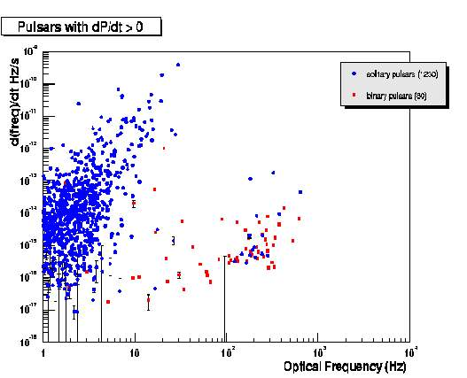
with G Newton’s gravitational constant, c the speed of light, I_{zz} the principal moment of inertia of the star and f the frequency of the wave. The ellipticity ε is the most uncertain factor. It is the deviation from an undeformed circular equatorial cross section of the star, which creates the quadrupole moment. Upper limits for ε can be obtained from the spin-down of the star, by completely assigning the energy loss to the emission of GW’s. From the maximum strain the crust of a NS can bear, one derives another upper limit of about 10⁻⁵. For a typical NS with a rotation frequency of 50 Hz (f=100Hz), at the centre of our galaxy (r=10 kpc) and ellipticity in the order of 10⁻⁶, the amplitude:
Fig. 2a.5 1 Frequency versus spin-down for all known pulsars, with positive spin-down parameter. The red dots represent pulsars in binary systems.
$h≈{\text{10}}^{−\text{27}}$ 2a.5 2

To detect such a small signal, a long integration period is needed. Note that many pulsars are much closer than this: the closest known pulsar is at a distance of 0.2 kpc, which would lead to a value 50 times larger for h.

Fig. 2a.5 1 shows that most of the known pulsars have too low frequencies to emit detectable GW’s. Of the pulsars inside the interesting frequency band about 60% is a member of a binary system. According to GR, a binary system radiates GW (see Hulse-Taylor above). The frequency of this emission is the orbital frequency, which is order of 10⁻⁴ Hz and thus far below the frequency range of Virgo. Independently from this orbital GW, the NS in a binary system can emit GW at (twice) its own spin-frequency. The presence of a companion gives the possibility of accretion and the emission mechanisms of accreting stars may be different than those of isolated NS. For these reasons, one must not exclude binaries from a search, even though, as explained in the next section, the analysis for binary systems is more complicated.

2b. Approach
2b.1 The signature of GW’s from NS’s

GW’s from rotating NS’s will cause a periodic signal in the data. The common technique to detect a periodic (sinusoidal) signal in a noisy time spectrum is to Fourier transform the data to the frequency domain, such that the signal will end up at one frequency over a white noise. Integration over long time intervals allows to accumulate sufficient power of the weak signal of GW’s from NS’s, such that it stands out over the background. However, various sources cause a frequency shift of the GW’s, thus spreading the signal and decreasing the signal over noise ratio. First, the Doppler shifts due to the relative velocity of the detector with respect to the source, coming from the daily and sidereal rotation of the earth, are well known and can be calculated for every sky-position. Secondly, the spin-down of the source, in spite of being a small effect (see Fig. 2a.5 1), is detectable after one year of integration. A third distortion comes from glitches, sudden changes in the rotation frequency of the star and linked to star quakes. This effect cannot be predicted, but is known to happen very rarely.

In binary systems additional effects are present. First of all, the Doppler shift due to the orbital movement must be taken into account. Other effects are the Roemer delay for the difference in travel time of the GW due to the varying distance between the NS and the detector, and the much smaller Shapiro delay for the change of metrics if the source of the GW is in the line of sight with the accompanying star[6]. These effects can be more pronounced than Earth motion effects, with up to 0.03 Hz frequency shifts. Evidently, these shifts complicate the detection of GW’s from such sources.

2b.2 Data Analysis

The most simple approach consists of a search for signals from known pulsars. Since the sky positions of these sources are known, one can calculate the Doppler shifts due to the detector movements for each individual source, and correct the data accordingly. LIGO has published upper limits on the GW emission for 28 known pulsars [7]. The upper limit for one nearby pulsar, determined with this limited observation time (2 months), is already close to that fixed by the spin-down, thus the measurement is approaching astrophysical interesting regions. For a detection of GW’s from known pulsars in binary systems, one must also correct for the Doppler shift due to the binary rotation. These parameters are in general less well known, thus for a search for GW’s from known binary systems also some fit of the rotation parameters is needed. A first attempt of such analysis on the X-ray binary Scorpius X-1 has been published by the LIGO collaboration[8].

The number of known pulsars is much smaller (~10⁶) than the expected total number of NS’s in our galaxy. And of the about 1600 known pulsars, only about 100 fall into the accessible frequency range of Virgo and LIGO. It is very likely, or at least possible, that the strongest GW emitter cannot be or has not yet been observed electro-magnetically. To incorporate also the yet unseen NS’s, one needs to perform an “all-sky” search including all possible source parameters. Due to the large parameter space, this is a huge computational challenge. Frasca [9] has shown that for 1 year of data taking, if a sufficient fine grid for all parameters is used, this would need a computing power of about 10¹⁹ TFlops (1 TFlop is 10¹² calculations per second). This is clearly not feasible and smarter algorithms are needed.

Evidently, every algorithm for an all-sky search must be a trade-off between sensitivity and detection probability on the one hand and computing time on the other. One could for example restrict the search to a small frequency band or a certain part of the sky, thereby decreasing the probability of detection. Most suggested methods up to now trade a small loss of sensitivity for a large gain in computing time by preselecting candidates. I shall discuss in some detail the hierarchical method for isolated NS’s as developed by Frasca et al.[9], which is similar to the method already used in a LIGO paper. This method includes a number of aspects which will probably be used in a final data analysis algorithm.

The hierarchical method [9] is based on alternating coherent and incoherent steps. In the coherent steps, the data is split into short time intervals, that are Fourier transformed individually. The length of the time integration is such that in spite of the various Doppler shifts the frequency of a signal still ends up in one bin. In this way a database of spectra or Short Fourier Transforms (SFT) is created. When stacked together the SFT’s form a time frequency plane in which a signal appears as a pattern depending on the Doppler shifts due to the earth movements and the spin-down parameters of the source. The incoherent step consists of a pattern recognition algorithm to select candidates. The chosen method is a Hough transform, which maps the frequency/time points to parameter space, the parameters being the two coordinates of the sky-position, the frequency and the spin-down. The resulting peaks in parameter space correspond to possible candidates. For all selected candidates the data is corrected, after which the procedure can be repeated for longer time intervals. This method is proven to be computationally feasible, while the loss in sensitivity for isolated NS’s is only a factor 2-5 [9].

For binary systems there are 3 extra parameters (the phase and the frequency of the orbital movement and the relative position of the plane of rotation with respect to the earth), which complicates the analysis. Other effects (such as the Roemer and Shapiro delays) have to be included as well. The method sketched above has not been studied for binary systems yet.

A substantial improvement can be accomplished by splitting the total dataset into two sets of about equal length in time. After the incoherent step, the data of the two sets can be correlated, thereby reducing the number of fake candidates by very large factors (~10³). Another interesting suggestion is to correlate the data between two or more detectors. Most suggested methods do not exploit the fact that the various frequency corrections, apart from the spin-down, are in itself periodic functions. Exploiting the well established existing data analysis techniques for periodic signals (e.g. Fourier transforms or wavelet decomposition) may be a powerful tool, especially for unknown binary systems. For binary systems, the only knowledge about the Doppler shifts, apart from limits on the amplitude and frequency, is that they are periodic.

2b.3 Approach

At present, only first steps have been set to distil the weak signals of periodic sources out of the data of GW detectors, and especially the sources in binary systems have been badly neglected. The research proposed here is in first instance to develop viable and sensitive algorithms. The current algorithms and ideas need to be investigated and improved, and new algorithms, especially for binary systems, must be developed. To develop new ideas a thorough understanding of the detector and the signature of the signal is necessary. Studying the signature will be done by simulations. By modulating the mirror positions an artificial signal can be produced in the data, thereby simulating the signal in the realistic environment. I also propose to investigate the signal by first performing the less complicated task of analysing the data for a selected set of known sources, specifically known binary systems, for which the Doppler shift corrections to some extent are known. An all-sky search will use independent computing steps for the different sky locations and GW frequencies, which makes it very suitable for Grid computing.

2c. Innovation

The first direct detection of GW will be a major discovery. The extreme densities inside a NS makes it an attractive object to study the physics in such an environment. Closer investigation of the signal from NS’s will provide input for the current models and theories about these stars. Furthermore, the detection of GW’s provides a test case for GR and more recent extensions to this theory [10].
As stated before, GW’s open a new window to the Universe and part of the proposed work will be an input for the upcoming LISA experiment. Although the frequency acceptance of LISA is in a lower range than that of earth-based detectors, pulsars will also be studied by LISA, mainly as calibration sources. Hardly any research has been done on data analysis techniques for binary systems yet, although these systems are promising sources of detectable GW’s. I shall specifically look into the signature of binary systems.
Sometimes, computational problems in physics lead to algorithms that can be used elsewhere. A good example is the Hough transform, which was originally developed for the recognition of tracks in bubble chambers, but is a now a widely used pattern recognition technique. The proposed research will concentrate on algorithm development, which could lead to solutions that are applicable in a much wider field.

2d. Plan of work

The proposed research requires simulations, a good understanding of the signal and the detector, software development and very likely Grid computing. The work will be done in collaboration with the Virgo data analysis groups amongst which the Nikhef/VU Gravitational Waves group. I propose to perform the research with, apart from applicant, two more persons. A PhD student will concentrate his efforts on the data analysis of known systems, specifically known binaries. Even if this would only lead to upper limits on the amplitude of the signal of such systems, this would still be a challenging task with excellent opportunities for a first-rate PhD thesis. A Post-doc will help in the development of algorithms and implementation in the Grid computing environment. Since it probably will be hard to find a post-doc with enough expertise in the GW field, a minimum of three years is required for this position. This will give the candidate the opportunity to spend the first year on getting familiar with the detector and the specific physics involved. The Nikhef provides a good environment for this research, since the institute is already involved in the data analysis and the hardware development of the Virgo experiment. A strong collaboration with the GRID computing group at Nikhef is foreseen.

2e. Literature references
- Hulse, R.A. and Taylor, J.H., Ap. J. Lett 195, L51 (1975);
Taylor, J.H. and Weisberg, J.M. Ap. J. 253, 908 (1982);
Weisberg, J.M. and Taylor, J.H., Phys. Rev. Lett. 52, 1348 (1984).
- Weber, J. (1960), Phys. Rev. 117, 306-313.
- Cutler, C and Thorne, K.S., gr-gc/0204090 (2002).
- Manchester, R. N., Hobbs, G. B., Teoh, A. & Hobbs, M.,
Astron. J. 129, 1993-2006 (2005).
- The LIGO Scientific Collaboration, gr-qc/0605028 (2006). And references therein.
- van Straten, W., Bailes, M., Britton, M., Kulkarni, S.R., Anderson, S.B., Manchester, R.N., Sarkissian, J.,
Nature 412, 158-160 (2001).
- Abbott et al, The LIGO Scientific Collaboration.
Phys.Rev.Lett. 94 181103 (2005).
- The LIGO Scientific Collaboration, gr-qc/0605028 (2006).
- Papa, M.A., Astone, P., Frasca, S., Schutz, B., Proc. 2nd Workshop on Gravitational Wave Data Analysis 241 (1997);
Frasca, S., Int. J. Mod. Phys. D 9 369 (2000);
Frasca et al., Class. Quantum Grav. 21 S1645-S1654 (2004).
- ??

Cost estimates

3a. Budget

 | 200y | 200y+1 | 200y+2 | 200y+3 | 200y+4 | TOTAL
Staff costs: (in k€)
Applicant
Post-doc
PhD student
Support staff
Non-staff costs: (k€)
Equipment
Consumables
Travel and subsistence
Other
TOTAL

3b. Indicate the time (percentage of fte) you will spend on the research
I will spend 100% of the time on the research (1 fte)

3c. Intended starting date
summer 2007.

3d. Have you requested any additional grants for this project either from NWO or from any other institution? no

Curriculum vitae

4a. Personal details
Title(s), initial(s), first name, surname: Dr. Maaijke Mevius
Male/female: female
Date and place of birth: 24-09-1971, Delft
Nationality: NL
Birth country of parents: NL

4b. Master's (‘Doctoraal’)
University/College of Higher Education: Utrecht University, Physics and Astronomy faculty
Date: 31/08/1997
Main subject: Foundations of Physics

4c. Doctorate
University/College of Higher Education: Utrecht University/ FOM
Date: 02/04/2003
Supervisor (‘Promotor’): Prof. Dr. P. Kooijman
Title of thesis: Beauty at Hera-B. Measurement of the bb Production Cross Section in pN Collisions at √s = 41.6 GeV.

4d. Work experience since graduating
June 2003 - Jan 2005 Research Fellow at Desy, Hamburg. Full-time, fixed-term.
Feb 2005 – March 2006 Scientific Programmer ASTRON, Dwingeloo. Full-time,
fixed-term
April 2006 - Post-doc Kapteyn Institute, RijksUniversiteit Groningen.
Full-time, fixed-term.

4e. Man-years of research
Three years and seven months.

4f. Brief summary of research over last five years

Post-doc at Kapteyn Institute and Scientific Programmer ASTRON. Working on LOFAR self-calibration.
Currently I develop the software for the self-calibration of the LOFAR radio-telescope. Calibration, in this case, not only involves the detector response, but any distortion of the signal (e.g. the phase shifts due to ionospheric interaction). My main task is to develop smart and fast algorithms that can deal with the huge data stream of LOFAR. The software is tested on the data of the Westerbork radio-telescope.

Research Fellow at Desy. Working on Hera-B data analysis.
As a post-doc at Desy I measured the b production cross section with a much larger dataset than the one used for my PhD thesis. I was also involved in the Charmonium analysis as coordinator of the Charmonium analysis group.

PhD student. FOM/University Utrecht. Working on the Hera-B experiment.
For my thesis I analysed the statistically limited dataset of the Hera-B 2000 physics run. With this data I was able to establish a small (~7events) signal of events in which a b-quark pair was produced and I measured the b-quark production cross section. This result contributed significantly to the first physics publication of the experiment.

It is obvious that my experience does not include GW physics. However, apart from good insight in the physics involved, the proposed research requires very good computing skills. My experience at LOFAR will be very useful in this sense.

4g. International activities

Of the past eight years I spent about four at Desy in Hamburg in the international Hera-B collaboration. I presented my work at several international conferences.

4h. Other academic activities

4i. Scholarships and prizes

List of publications

5. Publications:

- Average impact factors for your own field (only compulsory if your proposal is to be submitted to Medical Sciences, see Notes).

- International (refereed) journals
- C. Bauer et al. 2000. Nucl.Instrum.Meth. A 447 61-68 (2000).
- The HERA-B Collaboration, Eur.Phys.J.C 26 345-355 (2003).
- The HERA-B Collaboration, Phys.Lett.B 561 61-72 (2003).
- The HERA-B Collaboration, Eur.Phys.J. C 29 181-190 (2003).
- The HERA-B Collaboration, Phys.Lett. B 596173-183 (2004).
- The HERA-B Collaboration, Phys.Rev.Lett. 93 212003 (2004).
- The HERA-B Collaboration, Phys.Lett. B 638 407-414 (2006).
- The HERA-B Collaboration, Phys.Rev. D 73 052005 (2006).
- The HERA-B Collaboration, Phys.Lett. B 638 13-21 (2006).
- The HERA-B Collaboration, Phys.Lett. B 638 415-421 (2006).
- The HERA-B Collaboration, hep-ex/0606049 (2006)

- National (refereed) journals

- Books, or contributions to books
conference proceedings:
- M.Mevius, Nucl.Phys.Proc.Suppl. 115 157-161 (2003).
- M.Mevius, AIP Conf.Proc. 756 363-365 (2005)
- A. Zoccoli for the Hera-B collaboration, Eur.Phys.J. C43 179-186 (2005).
- Adass 2005
- Other

Signature

I hereby declare that I have completed this form truthfully:

Name:

Place:

Date:

Please submit the application to NWO in electronic form (pdf format is required!) using the Iris system, which can be accessed via the NWO website (www.nwo.nl/vi).
ALWAYS POST THIS PAGE TO NWO

Post to NWO

In order to counter check electronic submissions, please complete the form below and post a print-out of this page together with any relevant documents to NWO to arrive no later than the submission deadline. Always post this page before the deadline, even when no other paper documents have to be sent.

I, the undersigned declare that I have today posted (tick relevant documents):

Institutional guarantee from Board of host institution (‘Inbeddingsgarantie College van Bestuur’)
(to be sent by post, optional for Vidi during the application procedure)

Address list of ‘non-referees’
(to be sent by post before submission deadline, optional for all applicants, maximum 3 names, see Notes)

Name of applicant:

Place:

Date:

Postal address:

NWO Council area: ALW / CW / EW / GW / MaGW / MW / N / TW

Send the documents to:

NWO/Vernieuwingsimpuls
Council area: (fill in the area of your choice!)
P.O. Box 93138
2509 AC The Hague
(The Netherlands)

Laan van Nieuw Oost Indië 300
2593 CE The Hague

This is not true for accreting stars, since there the spin-down is partly compensated.
It is this spin-frequency of the pulsar, not the orbital frequency of the binary system, which is plotted in Fig. 2a.5.1
As a comparison, the Lofar supercomputer in Groningen calculates at a rate of 27 TFlops.
“Coherent” indicates a computing step where all source parameters are taken into account explicitly, thus where no information is lost.

