Gravitational-Wave Astrophysics

Main goal
The main goal of the project is to observe gravitational waves (GW), and subsequently, exploit their observation to address open questions in astroparticle physics. To achieve this goal we will contribute to the design, realization and optimization of experiments that feature both interferometers and a spherical GW antenna.

Scientific motivation
General Relativity (GR) is one of the most fundamental and beautiful physical theories. Yet it is poorly tested, as compared to other fundamental physical theories (e.g., quantum electrodynamics). One of the key features of GR is the dynamical nature of space-time itself: its curvature is a time-dependent quantity, and ripples of curvature can propagate through space-time with the speed of light. Such propagating curvature-ripples are called gravitational waves, and their existence is one of the most important, yet untested, predictions of GR. In our universe, GW are produced by unique astronomical events, such as mergers of pairs of black holes or neutron stars, and supernovae explosions. GW can be used to probe the evolution of such compact objects. Such data are entirely independent of any observation in the electromagnetic spectrum, and are therefore likely to lead to unique information on such compact objects, including for instance information on the equation of state of matter at extremely high densities. Moreover, GW propagate almost unperturbed through essentially the entire universe. This makes it in principle possible to detect GW-signals emitted essentially during the Big-Bang. Measuring the amplitude at different frequencies should give information on matter at energies around 10¹⁸ GeV, a scale that will never be reached by men.
As the spectrum and amplitude of GW sensitively depends on the details of the Big Bang models, i.e. inflationary fields causing rapid expansion of the universe' size, rapid collapse of cosmic strings, etc., such data will represent the first direct test of such models. Thus, detection and further observation of the GW would both provide important tests of GR and would open a new window for astronomical observations of fascinating cosmic phenomena.

GW-signals, however, are expected to be extremely weak (causing relative displacement of free masses by distances which are a tiny fraction of the size of an atomic nucleus), and thus enormous technological challenges have to be overcome in order to make a detection. Large resources all over the world have been committed to building several types of gravitational-wave observatories. Each type has its own frequency range in which it has high sensitivity to the GW, and thus different types of detectors target different types of astronomical sources. Also, an essential theoretical effort has been exerted to predict and model the cosmic sources of Gravitational Waves. Netherlands has significant established or emerging expertise on both the technological and theoretical sides of gravitational-wave astronomy. This proposal aims to overview Dutch efforts which are already ongoing, and to identify the specific areas which need further investment in instrumentation and/or manpower.

Objectives
Experiments designed to observe (and hence discover!) gravitational waves come in two types: Resonant detectors and interferometers.

Resonant detectors have specific dimensions (in the form of a bar or a sphere), and are therefore only sensitive to the passage of gravitational waves having a frequency component that falls in a very narrow close to 1 kHz. At present several resonant gravitational wave detectors are operational: ALLEGRO, AURIGA, EXPLORER, NAUTILUS, NIOBE, MARIO SCHENBERG and the Dutch experiment MiniGRAIL in Leiden.
We will be involved in developing the MiniGRAIL spherical gravitational wave antenna and the associated techniques so as to approach the calculated strain spectral amplitude of a few 10⁻²³/√Hz in a band ranging from 2.7 to 3 kHz. In this range of frequencies it can be the most sensitive GW detector for the 6-7 years to come. We will develop the cryogenics to cool very large masses to the low milli-kelvin range, not only for MiniGRAIL and other (larger) spherical resonant detectors but also for dark matter research, double-beta decay, infra-red astronomy, etc. Leiden Cryogenics (LC) was already involved in the design and construction of the cryogenics for the SCUBA-2 telescope and the VIRGO cryostat for testing the cooling of the mirrors. LC has a major role in the field of powerful dilution refrigerators and could further improve its position in the field if this project is granted. They have also expertise in the field of sensitive measurements particularly SQUIDs.

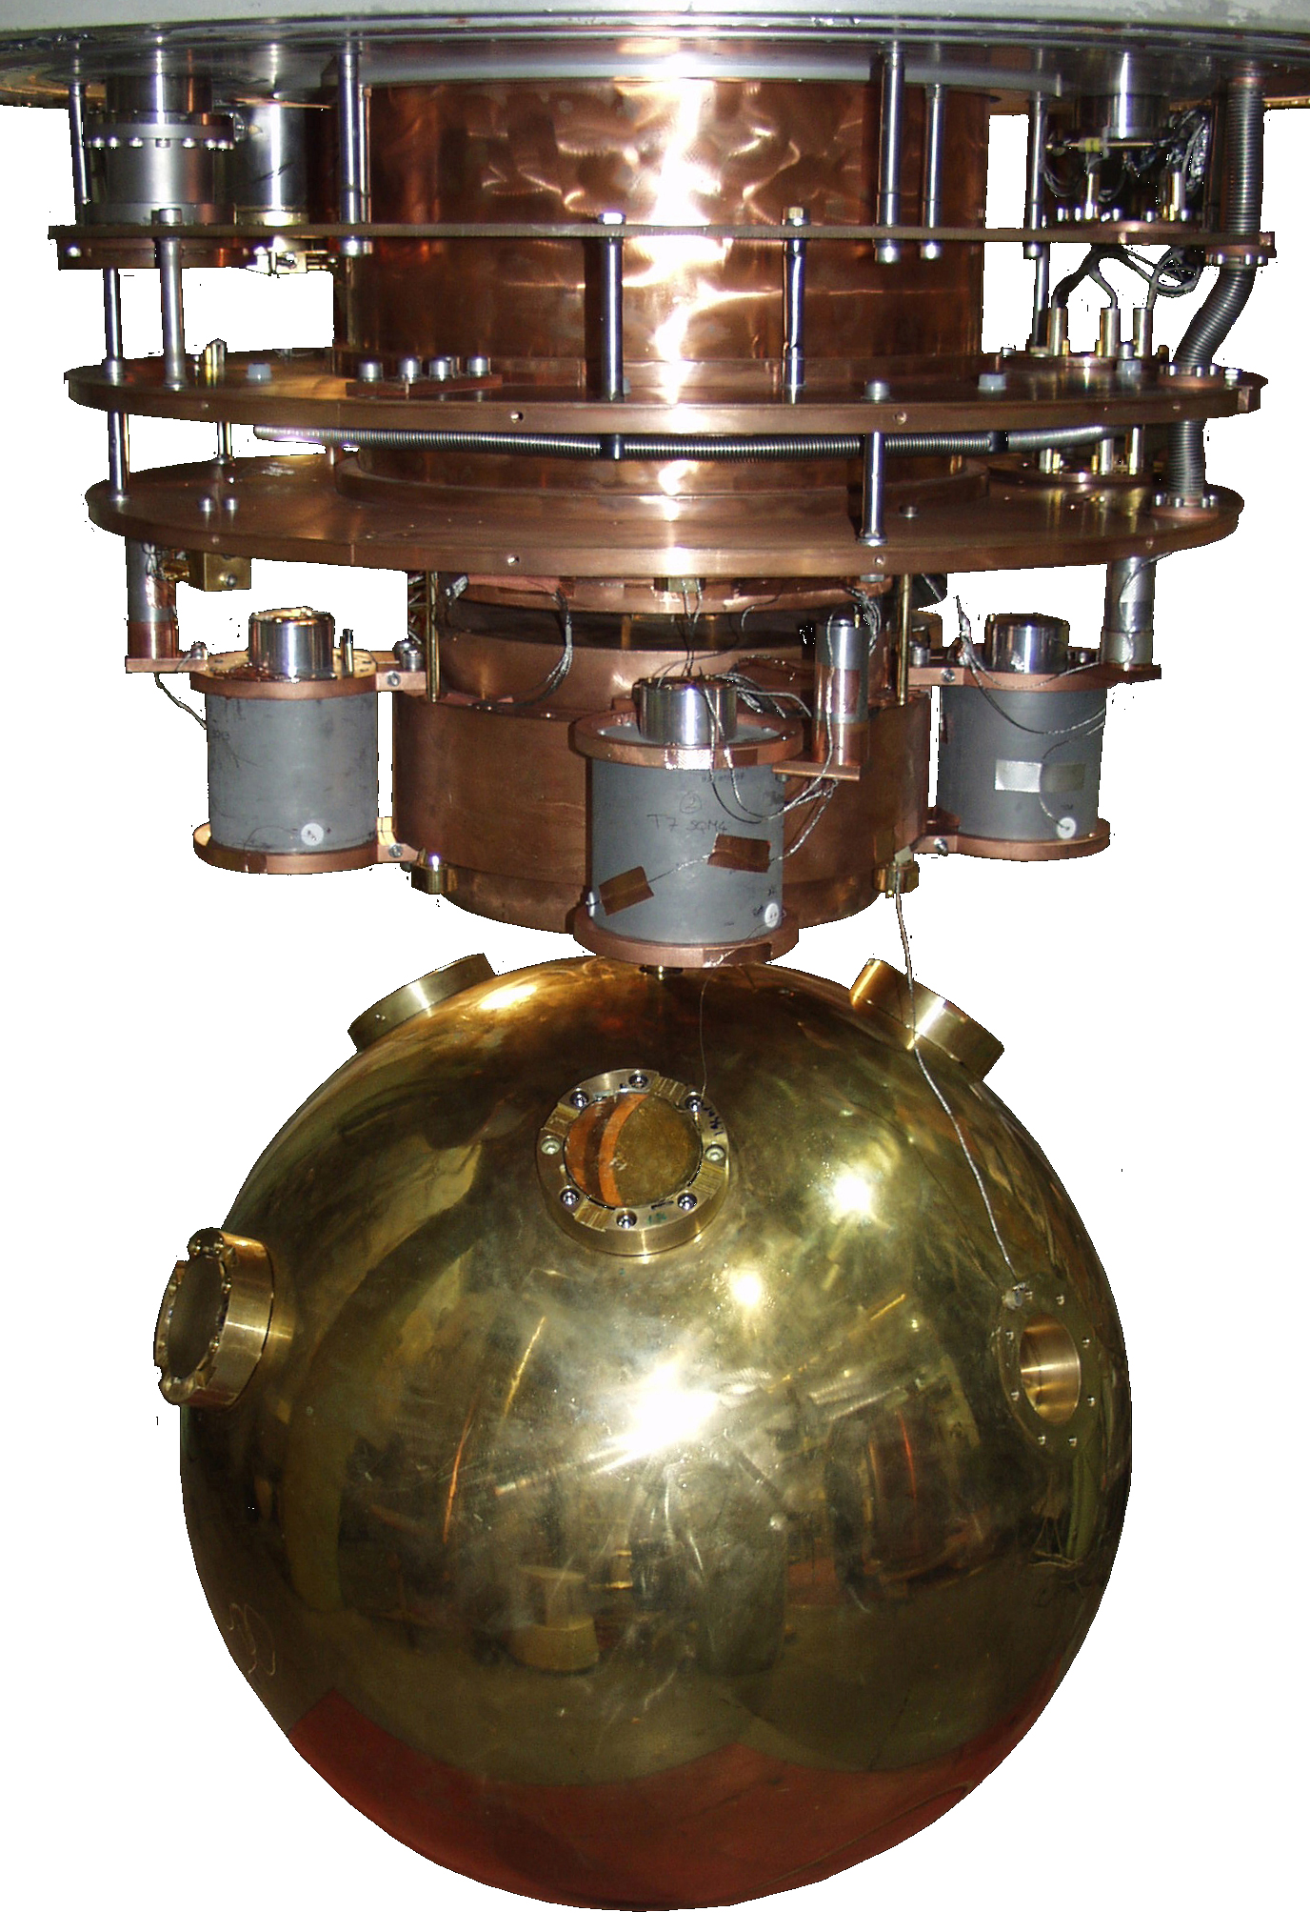

MiniGRAIL is a 1.4ton CuAl spherical detector cooled to below 60 mK that will be very sensitive
at a frequency around 2.9kHz over a bandwidth of 300 Hz. It is the first spherical GW antenna in the world and can be the base for lower frequency detectors of unprecedented sensitivity that would
be complementary to the interferometers

Interferometers are based on measuring the effects of GW on the interference pattern of a laser beam. In such a device, a laser beam is split by a mirror and travels a number of times up and down between the mirrors of two arms creating an interference pattern where it recombines. A photodiode looks at the position where the two beams meet destructively forming a dark fringe. A change in the path length due to a passing GW can be deduced from a change of the intensity of the dark fringe. The most sensitive GW detectors at present are the two-arm interferometers of the LIGO group in the USA. We participate in VIRGO, a European project realized by a collaboration between Italian and French researchers, that is expected to reach a comparable sensitivity this year. The scientific objective is to detect GW that are expected to be emitted by neutron star mergers, supernovae, and rapidly spinning neutron stars.
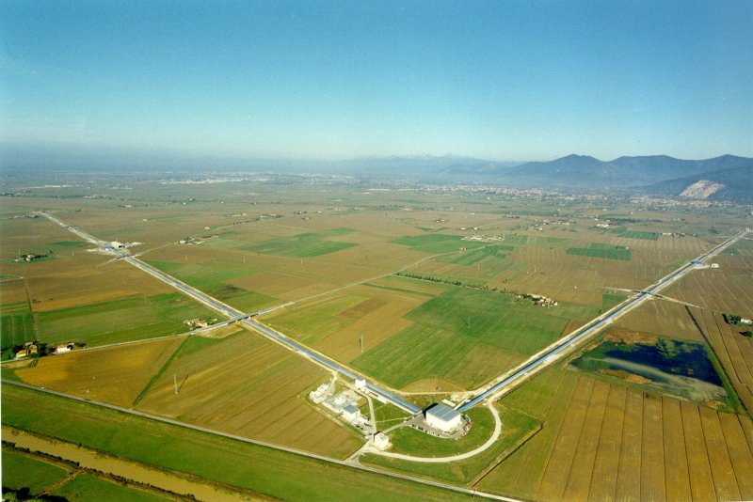

Fig. 2. The Virgo interferometer near Pisa, Italy, consists of two 3 km long arms.

Ultimately, satellite-based interferometers will be able to study in detail GW signals from any object of sufficient mass, no matter how exotic. This will enable the observation of the coalescence of massive black holes and signals from white dwarf binaries. Moreover, it may allow for fundamental tests such as to probe primordial GW from the earliest cosmological time periods and examine the validity of string theory, which says that there are more than four dimensions to space-time and that the extra dimensions are hidden. We participate in the satellite-based interferometer project, LISA, which has three satellites, positioned 5 million km apart, in orbit around the sun. It is clear that projects such as LISA are of fundamental importance for the development of GW astronomy.

Work Packages
The project consists of a number of distinct work packages or tasks. Each of these work packages will be carried out by a limited number of partners of the consortium and/or with some scientific groups from elsewhere in Europe. The groups involved, and the amount of additional manpower (i.e. directly financed by the requested subsidy) are listed as well.

Work package 1: Analysis of scientific data obtained with VIRGO
VIRGO is a Michelson type interferometer with a base-length of 3 km. It has been built by a French-Italian collaboration at Cascina close to Pisa. VIRGO is about to start to take data and is likely to observe for the first time ever directly the effects of gravitational waves, i.e. the deformation of space-time due to changes in acceleration of masses. The VU-NIKHEF group has been invited to join VIRGO and we have enthusiastically accepted this exciting possibility.
VIRGO searches for GW-signals from the coalescence of binary systems (containing neutron stars of black holes) or the explosion of a supernova. We will concentrate our efforts on the search for gravitational waves emitted by pulsars, including those bound in binary systems. Such pulsars are periodic sources of GW with a (near) constant frequency over long time periods. This allows to enhance the effective strain sensitivity by several orders of magnitude.

Partners: NIKHEF, VU.
  - Required annual resources: 1.0 Postdoc, 3.0 PhD students, 100 k€ for use of foreign measuring devices, 20 k€ materials (at a subsidy level of 100%),12 k€ travel and exchanges (50% subsidy level)
  - Duration: 2007 - 2011

Work package 2: Modeling and distributed data analysis with VIRGO and LISA
Data analysis for gravitational wave detectors is cpu-intensive. In the case of VIRGO one would like to perform an all-sky search to detect signals from periodic sources. Since the frequency of the gravitational wave is modulated by the daily axial rotation of the earth and by the orbital motion around the sun, such a search requires a direction-dependent correction at all frequencies. A theoretically optimal search over 1 year of data would require billions of Tflops. For LISA, large-scale computing is needed to describe and disentangle the spectrum at low frequency where the signals from millions of galactic binaries will contribute into the LISA frequency bandwidth. The evolution of white dwarf binaries needs to be modeled in order to be able to predict the number of galactic sources that can be discovered by LISA and their contribution to the background noise. This will contribute to the further definition of the parameters of the instrument. Furthermore, a proper understanding of the tidal interactions in binaries needs to be available for a comparison between LISA data and predictions. Efforts are starting to develop strategies for complementary electro-magnetic observations that will greatly help the data analysis for LISA and detailed studies of know binaries that will be used as verification sources are underway.
Clearly, other potential sources of gravitational waves, such as black hole mergers, need to be studied as well. The waveform depends on several parameters (such as the masses and angular momenta of the black holes) and one needs a reasonable amount of calculated templates in order to extract the relevant information from an observed event. In order to facilitate such cpu-intensive calculations, we plan to make use of grid technology. We want to incorporate the relevant software packages (from VIRGO and LISA collaborators) into the EGEE (Enabling Grids for E-sciencE) grid. The availability of a large EGEE grid center at SARA/NIKHEF and the support of their grid technology software engineers enables this activity.
  - Partners: NIKHEF, RU, SRON and VU.
  - Required annual resources: 2.0 Postdocs, 4.0 PhD students, 20 k€ materials (at a subsidy level of 100%), 20 k€ travel and exchanges (50% subsidy level)
  - Duration: 2007 - 2011

Work package 3: MiniGRAIL: optimizing a spherical gravitational wave detector
Improvement of MiniGRAIL sensitivity and stability, including transducers and cryogenics. We will be aiming at a sensitivity higher than that of the best interferometers in a 10% band around 2.9kHz. Since the interferometers, particularly LIGO in the US and VIRGO in Italy have reached their designed sensitivity and since there will be a gap of 5-6 years before the upgrading to LIGO 2 (or VIRGO advanced) there is a good chance that MiniGRAIL can contribute significantly to the field with even the possibility of being the first to detect gravitational waves. Many interesting sources are predicted to emit gravitational waves in the kHz region, like bar-modes instabilities of neutron stars, small black hole perturbations or coalescences. MiniGRAIL can potentially look at a volume 100 to 1000 times larger than that of the present interferometers.
  - Partners: Leiden Cryogenics, UL and VU.
  - Required annual resources: 1.0 Postdoc, 5 k€ materials (at a subsidy level of 100%), 5 k€ travel and exchanges (50% subsidy level)
  - Duration: 2007 - 2011

Work package 4: Development of SQUID sensors
Development of SQUID sensors also in combination with reliable and easy to use dilution refrigerators, aiming at reaching the quantum limit at kHz frequencies. Here, new approaches will be tested for reaching the quantum limit, particularly cooling the electrons of the shunt resistors to low milli-kelvin temperatures. This might require ion-implanted resistors in the bulk of the silicon wafer. This research is closely related to the WP-3.
  - Partners: Leiden Cryogenics, UL and VU.
  - Required annual resources: 1.0 Postdoc, 1.0 R&D engineer, 30 k€ materials (at a subsidy level of 100%), 5 k€ travel and exchanges (50% subsidy level)
  - Duration: 2007 - 2011

Work package 5: The LISA-Pathfinder project
One of the technologies to be tested with LISA Pathfinder is the Inertial Sensor system. This system comprises a cubic, conducting proof mass and a surrounding system of electrodes that capacitively measures minute displacements of the proof mass relative to the spacecraft. Inertial Sensors cannot be fully tested on the ground, due to the Earth's gravitational pull on the proof masses in the laboratory. SRON is therefore developing special test equipment – an “Inertial Sensor Test Module (ISTM)” – that will be used to simulate the Inertial Sensor read-out electronics with realistic sensing signals during on-ground tests of the LISA Pathfinder system. In fact, the read-out and control electronics of the ISTM therefore have an even better
performance than the in-flight electronics. SRON is also contributing to detailed software models of the Inertial Sensor, which are included in the industrial “End-to-End Simulator” being developed at EADS Astrium (Germany).
The expertise developed for the LISA-Pathfinder project will be used for an active Dutch role in the construction of the LISA gravitational wave satellite system.
  - Partners: Xensor and SRON.
  - Required annual resources: …
Duration: 2007 - 2011

Work package 6: Miniaturized inertial-sensor control & readout electronics
The core of the miniaturized inertial-sensor control & readout electronics (the mixed-signal ASIC for very high resolution and very low frequency data conversion) developed by SRON (and Dutch SME) is also a very promising technology to be applied in Seismometers for future Mars missions, and in the inertial sensors or accelerometers of the next generation of Earth gravity missions. The Seismometer is among the current baseline instruments of the approved ESA ExoMars mission (with realistic launch date around 2013). The main scientific questions are formulated within the framework of comparative planetology for which the seismometer will provide information on the radius, chemical composition and state of the Mars core, and radial layering of core, mantle and crust. The future gravity mission for which ESA (and NASA) studies are on-going is known as the Laser Doppler Interferometry Mission (LDIM), which will perform ultra precise measurements of the time variable gravity field of the Earth for the determination of mass displacements; examples includes patterns in sea level variation, hydrology and geodynamics. This type of mission will make use of laser interferometry between inertial sensors or accelerometers similar as for LISA.
Measurements making use of the LISA-type of inertial sensor read-out and control electronics are thus of immediate relevance for other fields of science such as planetary geophysics, comparative planetology, and Earth oceanography, hydrology and geodynamics. The planetary Seismometer is included in the Dutch national platform for planetary research (NPP) coordinated by the SRON program bureau and NIVR, the Netherlands’ Agency for Aerospace Programs. Both the planetary Seismometer and LDIM are part of the “Actieplan Ruimtevaart” of the ministeries EZ, V&W and OCW. The development of the LISA inertial sensor read-out and control electronics is build on the expertise developed in the running LISA-Pathfinder project and will be used for an active Dutch role in the construction of the LISA gravitational wave satellite system.
  - Partners: NIKHEF, SRON, TNO S&I.
  - Required annual resources: …
Duration: 2007 – 2011

Work package 7: Rapidly spinning neutron stars as sources and detectors of GW-signals.
Non-axisymmetric rapidly spinning neutron stars in our Galaxy are a promising source of potentially detectable GW. Sometimes such a neutron star is also a millisecond pulsar (i.e., it emits periodic radio-pulses every several millisecond). In this case, the extreme regularity of the pulses can be used to probe the presence of extragalactic long-wavelengths gravitational waves. Our package aims to study the neutron stars as both sources and detectors of GW:
Sources: Strongly accreting rapidly spinning neutron stars in Low-Mass X-ray may emit periodic gravitational waves detectable by LIGO and VIRGO. One possible widely-discussed mechanism by which the GW could be emitted is via the growth of the neutron-star r-modes. We will study in detail the physics of driving and damping of the r-mode instability, and the associated gravitational-wave signal.
Detectors: Binaries of supermassive black holes are predicted to exist at the centers of many galaxies, and their presence will be manifested by a background of low-frequency (periods of several years) gravitational waves. Pulsar Timing Arrays will use tens of millisecond pulsars in the Galaxy to measure the background of gravitational waves produced by the BH binaries. We will also investigate the possibility of detecting more exotic sources such as cosmic strings. We will work on the mathematical algorithm which will extract information about the gravitational waves from the Pulsar Timing Array data.
- Partners: LU
- Required annual resources: 2.0 PhD students.

Work package 8 – Antisymmetric metric fluctuations as dark matter
Primordial metric fluctuations of an antisymmetric metric field may be a more sensitive probe of inflationary scale than the primordial gravitational waves and furthermore represent a fine dark matter candidate, provided they have the right mass. We intent to investigate how the antisymmetric field interacts with relativistic gravitational potentials, and what are the distinct signatures of this novel dark matter on the CMBR and on large scale structure formation.
- Partners: UU
- Required annual resources: 1.0 PhD student.

Work package 9 – The role of radiative quantum corrections in cosmic inflation
Stochastic inflation is a formalism that allows in principle to perform a non-perturbative investigation of loop quantum corrections for various observables in cosmology, which include the effective cosmological constant (the inflationary Hubble parameter), the spectral index of cosmological perturbations, etc. The purpose of this project is to set rigorous foundations of stochastic formalism and to calculate the leading quantum radiative corrections to the relevant observables.
- Partners: UU
- Required annual resources: 1.0 postdoc.

Work package 10: Theoretical study of gravitational waves from double pulsars
The basic assumption behind quintessence –and many other models that attempt to explain the cosmological constant – is the existence of a fundamental cosmological scalar field that couples weakly to all forms of matter. Such a field may reveal itself through a correction of the gravitational radiation of e.g. double pulsars. The study investigates to what extent the very accurate observations of double pulsars can be used to place an upper limit on the existence of such scalar field quanta.
- Partners: NIKHEF
- No extra positions requested.

Valorisation and outreach
The combination of nearly quantum-limited SQUID with helium-free dilution refrigerators developed for the MiniGRAIL project, could make up a package that would provide unprecedented sensitivity for all kinds of sensors, particularly magnetic flux detectors. Here the market could be considerable, although difficult to estimate. Leiden Cryogenics have also developed and will be improving dilution refrigerators where the unit is completely made of plastic materials which are ideal for magnetic measurements in low magnetic field environments, including medical applications.

High precision interferometry has many applications. The state-of-the-art technologies for VIRGO have been developed in close collaboration with industry and have already impact on other scientific and industrial activities. Sophisticated seismic isolation systems and ultra sensitive accelerometers find many applications in other fields of science and industry. VIRGO houses the largest ultra-high vacuum chamber in Europe. The construction has required the development of special metallurgical production processes and the realization of large welded tube assemblies with a high accuracy. Extremely low diffusion optical coatings on large substrates are performed for the mirrors of VIRGO in a special coating facility in Lyon, France, which also attracts industrial clients. The extremely low absorption and high homogeneity required for VIRGO optics has triggered considerable improvement of the production process of fused silica.
Our analysis of pulsar signals draws heavily on the application of the Hough transformation (HT). The HT was proposed in 1959 for computerized pattern recognition in bubble chamber pictures and was granted a US patent in 1962. Twenty years later it started to play an important role in digital image processing (the field of Computer Vision). Applications of the HT extend from remote sensing (analysis of street patterns in photographs taken from space), over medical industry (automatic counting of specific blood cells), automatic lane detection for cars, to translation of hand-drawn (architectural) designs into construction drawings. Our combination of pattern recognition and large scale computing will certainly be very fruitful in many other applications.

The groups of Virgo, LIGO, and Lisa excel in outreach projects. We mention here theEinstein@Home project [Ref. 12] that offers participants a possibility to use idle time on their home computers to search for spinning neutron stars in data collected by the gravitational waves detectors.
Xensor, TNO S&I

Planning and timing
The chosen work packages are timely in various respects. The technology for detecting GW has advanced to such a level that detection of GW seems imminent, while as a follow-up large-scale satellite-based experiments are being prepared.

