Gravitational gradient signal of harmonic wave in line source
Eric Hennes, Januari 20, 2009

In this paper we calculate the GGN induced by a mass line source carrying a harmonic longitudinal wave. The result can be used to test a corresponding FEM model.

Analytical derivation of the GGN of a longitudinal wave through a mass line.
Let us assume a mass is distributed along the x-axis with constant density m. Through the line a longitudinal wave is moving into the positive x-direction:
- $$u(x,t)=u_{0}\text{cos}(ωt−\text{kx})$$
u₀ represents the wave amplitude, ω is the angular frequency and k=2π/λ is the wave number. At distance H from this line, at z=-H, we position the measuring point P (see Figure 1).
z
dM
u(t)
x₀
H
a
da

P

Figure 1. Forces on the measuring point P due to mass element dM, originally located at x₀

The gravitational acceleration in P due to a segment dM at position x can be written as:
- $$a(x)=\left(a_{x},a_{z}\right)=\frac{\text{GdM}}{(x^{2}+H^{2})^{3/2}}\left(x,H\right)$$
For small displacements (u₀<<H) the acceleration due to the displacement of dM can be written as:

- $$da(x,t)=\frac{da}{\text{dx}}u(x,t)$$

The total acceleration induced by the travelling wave is found by summing the contributions of all sections dM:
- $$a_{\text{wave}}(t)=\int{da(x,t)}$$

Evaluation of the x component of the GGN acceleration.
In order to evaluate the integral in (4) we evaluate the derivative da_{x}/dx :
- $$\frac{{\text{da}}_{x}}{\text{dx}}=\frac{\text{GdM}}{(x^{2}+H^{2})^{3/2}}\left(1−\frac{3x^{2}}{x^{2}+H^{2}}\right)$$
Using this and dM=mdx, the total acceleration due to an infinitely long mass line is found to be:
- $$a_{x,\text{wave}}(t)=\int_{−∞}^{∞}{\frac{{\text{Gmu}}_{0}}{(x^{2}+H^{2})^{3/2}}\left(1−\frac{3x^{2}}{x^{2}+H^{2}}\right)\text{cos}(ωt−\text{kx})\text{dx}}$$
This acceleration reaches its maximum at t=2nπ/ω, where n=0,1,2,… The amplitude can be expressed, thank to Maple, as:
- $$a_{x,\text{wave}\text{,max}}=\frac{2{\text{Gmu}}_{0}}{H^{2}}\left[k{\text{HK}}_{1}(\text{kH})−\frac{8G_{\text{13}}^{\text{21}}\left(\frac{k^{2}H^{2}}{4}|\begin{matrix}12 \\ 2,1,112\end{matrix}\right)}{k^{2}H^{2}}\right]$$
Where K₁(x) is the modified Bessel function of the second kind and G is a Meijer G function. Figure 2 shows the wavelength dependent factor as a function of λ/Η. The maximum acceleration shows up for λ=4.05H.
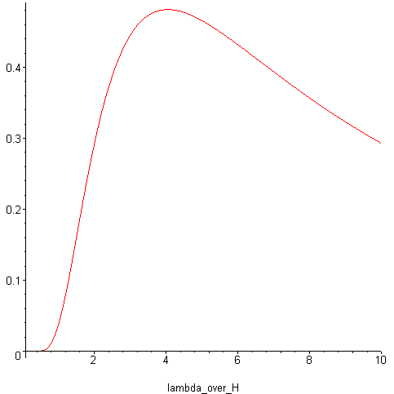
Figure 2. Acceleration amplitude of a_{x, wave} at distance H from a mass line, in units 2Gmu₀/H²

