CNRS | INFN
Centre National de la Recherche Scientifique | Istituto Nazionale di Fisica Nucleare

Measurements of the modes of the dihedron on the Injection Bench

P. Puppo

VIR-NOT-ROM-1390-306

Issue:1
Date: 11 November, 2005

VIRGO *Traversa H di via Macerata-56021 S. Stefano a Macerata, Cascina (PI), Italy.
Secretariat: Telephone.(39) 050 752 521 * FAX.(39) 050 752 550 * e-mail manuela@virgo.infn.it
The measurement

In the context of the new set-up of the Injection System, we have measured the mechanical modes of the dihedron placed on the new Injection Bench. The dihedron is placed, without any clamp, on three cylindrical legs having a diameter of 2mm and a spherical tip of 5 mm diameter. The dihedron contacts with the tips differ by shape: one is plane, on conic and one is linear. The measurement has been performed by using an optical lever looking at the dihedron displacements, whose signal is read by a PSD placed on the new bench. The measurements were performed during the third week of October 2005. The system was excited by a calibrated hammer hitting the base of the dihedron support. Then the transfer function between the induced displacement and the excitation were measured by using the Onosokki spectrum analyzer.
A first preliminary set of measurements were performed on a dummy dihedron (1) made of aluminum alloy, suspended by the thin legs, and placed on a commercial optical table. During this measurement run, the displacement induced by the calibrated hammer was measured by an accelerometer attached on the dihedron by wax. Moreover, with this set up, it was possible to hit on several points of the dihedron mass in order to reconstruct the displacement of each vibration mode.
We have observed three different frequencies, at which the coherence was near to the unity value. They are the three bending modes of the legs loaded by the dihedron. We have observed that the frequency values and their quality factors may change if the dihedron is misplaced by the legs and then it is positioned again on them. This can be explained by the slight modification of the mechanical contacts during this operation.
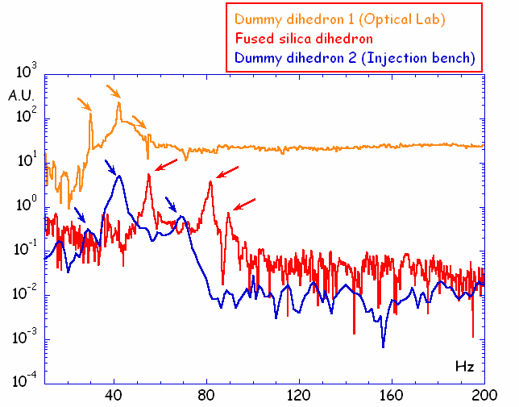
Figure 1

A second set of measurements were performed on the dummy dihedron (2) placed on the new injection bench in the class 100 clean room. In this case, an accelerometer was used to monitor the displacement as well.

In the figure 1 the results from the three sets of measurements are compared.

The mode frequency values measured on the dummy dihedron are 30 Hz, 42 Hz and 53.8 Hz for the dummy (1) and 30 Hz, 42 Hz and 68 Hz for the dummy (2). The frequency set measured on the Suprasil dihedron is 55 Hz and 81 Hz, 89 Hz.

Comments
By a comparison of the three sets of measurements, we have made the following observations.
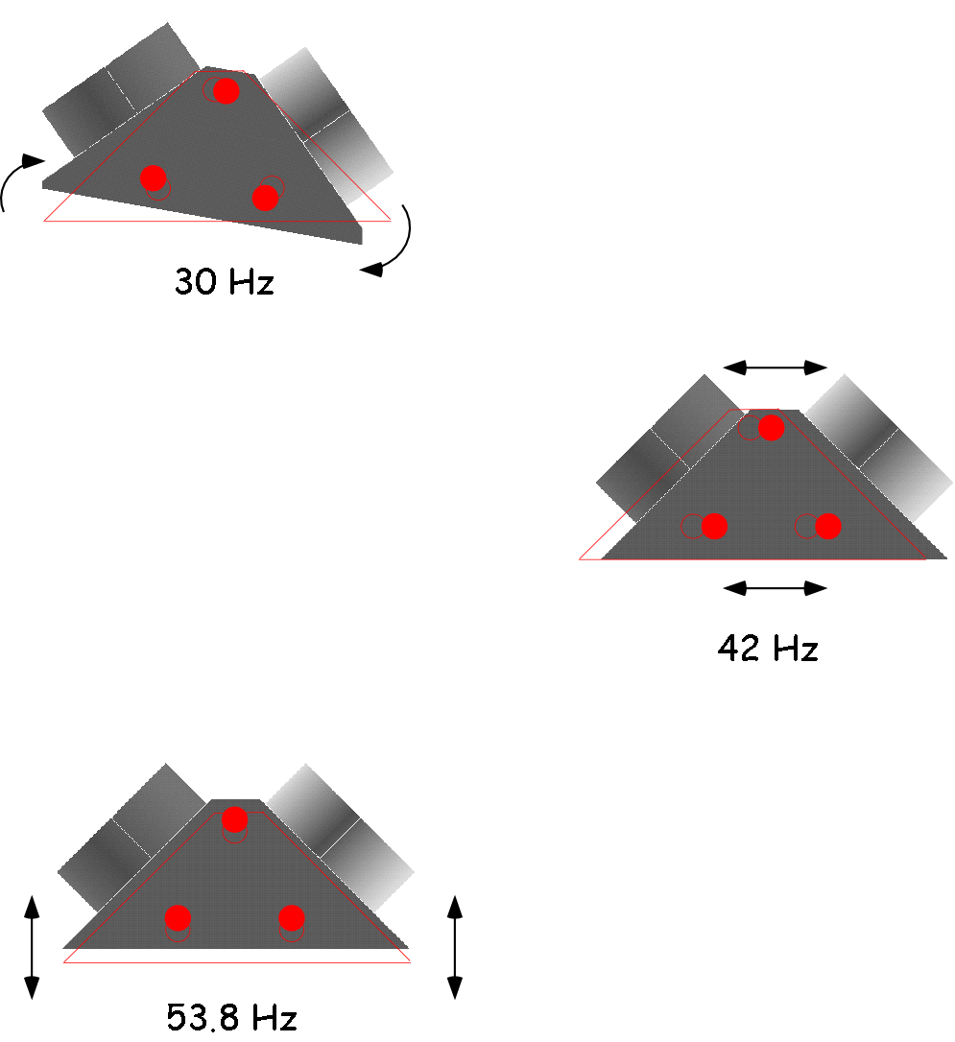
Figure 2

1) The mode shapes, identified by using the measurement run on the dummy dihedron (1), are shown in figure 2. The frequencies values shown in the figure refer to this set of measurement.
A strong coupling between the torsional and translational degrees of freedom was observed. For example, in the mode at 42 Hz is present a torsion about one of the legs (right one).

2) The frequencies measured on the dummy dihedron (2) are very similar to the previous case except for the frequency at 68 Hz.

3) The frequencies measured on the real dihedron are higher than the previous case and the quality factors are twice. The frequency change can be related to the difference between the masses of the aluminum and the Suprasil dihedron. The density of the aluminum alloy is 2.7 g/cm³ and the density of the Suprasil is 2.2 g/cm³. We then expect that the frequencies are a factor $\sqrt{2\text{.}7/2\text{.}2}=1\text{.}1$ higher, giving 33 Hz, 46.2 Hz, and 60 Hz. This is not sufficient to explain the measured values. This variation can be due to a different coupling between the dihedron and the suspension. For this reason, we cannot give a certain correspondence between the mode shapes measured on the dummy dihedron (1) and these frequency values. This behavior will be investigated by a FEM simulation where the three different contacts between the legs and the dihedron and the possibility to vary the friction coefficients on those points are included.

4) In figure 3 are compared the measurement of the frequencies visible at the mode cleaner output when the injection bench is excited at the level of the ground coils, and the frequencies measured on the Suprasil dihedron. Although the quality factors are very different, a qualitative correspondence between the three frequency values can be found.

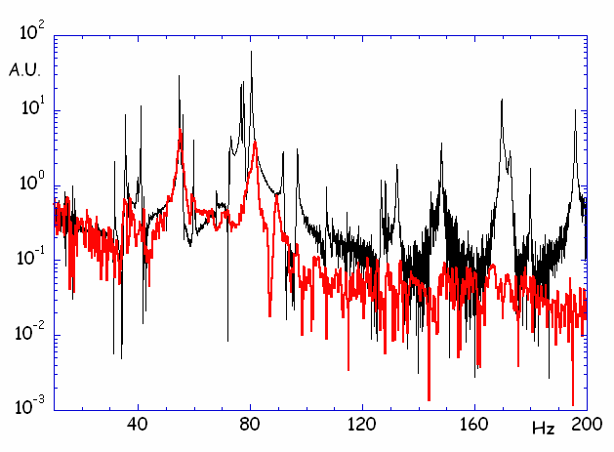
Figure 3
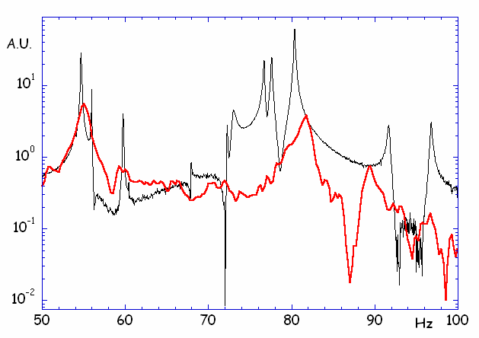
Figure 4 (zoom of figure 3)

