BOX / PALET | PARTS | INDEX | URL ADDRESS | PICTURES
1 | 2 | Blind flange bellow intern |  |  | 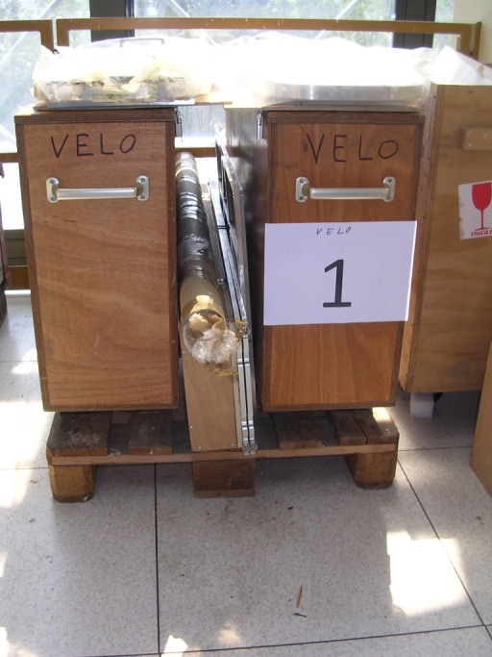
1 | 2 | Blind flange extern |  |  | 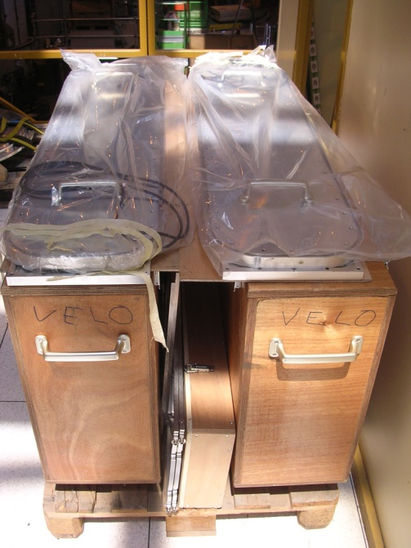
1 | 1 | Cu center tub |  |  | 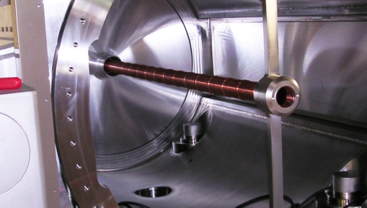
1 | 1 | Alignment box - R | http://www.nikhef.nl/pub/departments/mt/projects/lhcb-vertex/pdf/TVS-ALIGNMENT_AND_SURVEY/TVS03.pdf
1 | 1 | Measuring frame
1 | 1 | Alignment box - L | http://www.nikhef.nl/pub/departments/mt/projects/lhcb-vertex/pdf/TVS-ALIGNMENT_AND_SURVEY/TVS03.pdf
1 | 4 | Top referential frame | http://www.nikhef.nl/pub/departments/mt/projects/lhcb-vertex/pdf/TVS-ALIGNMENT_AND_SURVEY/TVS06.pdf

2 | 1 | End flange  Ø 910 mm | http://www.nikhef.nl/pub/departments/mt/projects/lhcb-vertex/pdf/TVV-VACUUM_VESSEL/VESSEL/TVV13.pdf |  | 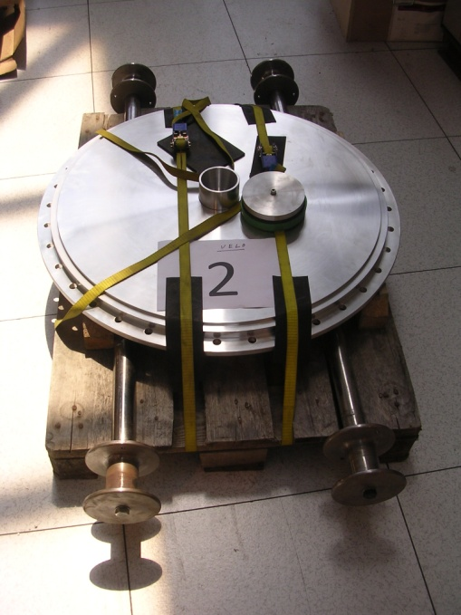
2 | 2 | Velo lifting axis | http://www.nikhef.nl/pub/departments/mt/projects/lhcb-vertex/pdf/TVL-LIFTING_DEVICES/STAND/TVL07.pdf
3 | 1 | Test flange + heather A - side | http://www.nikhef.nl/pub/departments/mt/projects/lhcb-vertex/pdf/TVV-VACUUM_VESSEL/VESSEL/TVV35.pdf |  | 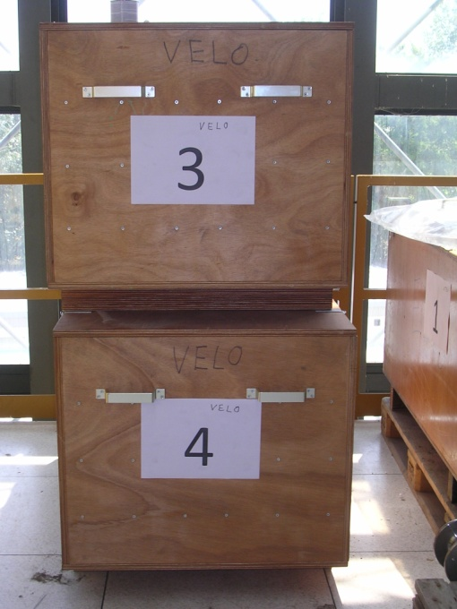
4 | 1 | Test flange + heather C - side | http://www.nikhef.nl/pub/departments/mt/projects/lhcb-vertex/pdf/TVV-VACUUM_VESSEL/VESSEL/TVV35.pdf
5 |  | Detector alignment frame |  |  | 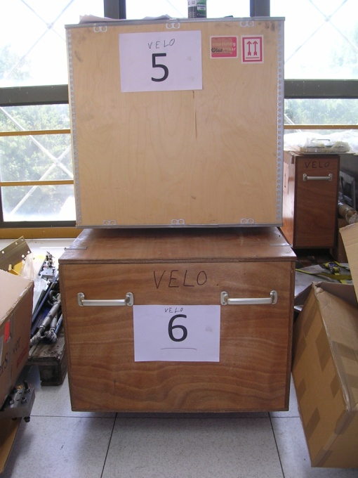
6 | 1 | Lifting devise | http://www.nikhef.nl/pub/departments/mt/projects/lhcb-vertex/pdf/TVL-LIFTING_DEVICES/DET_SUPPORTS/TVL14.pdf | 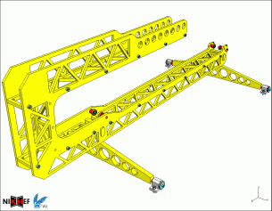
7 |  | Helicoflex |  |  | 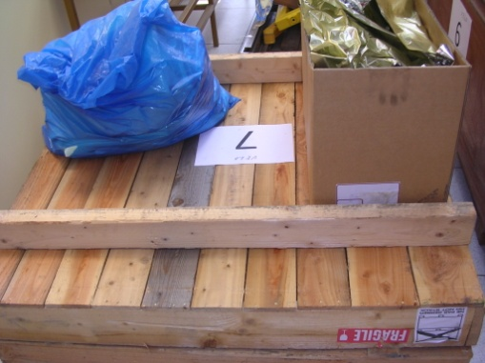
8 | 2 | Detector insert rail | http://www.nikhef.nl/pub/departments/mt/projects/lhcb-vertex/pdf/TVL-LIFTING_DEVICES/INSTALL_DET/TVL03.pdf | 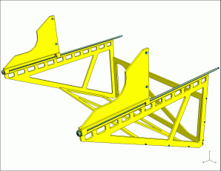 | 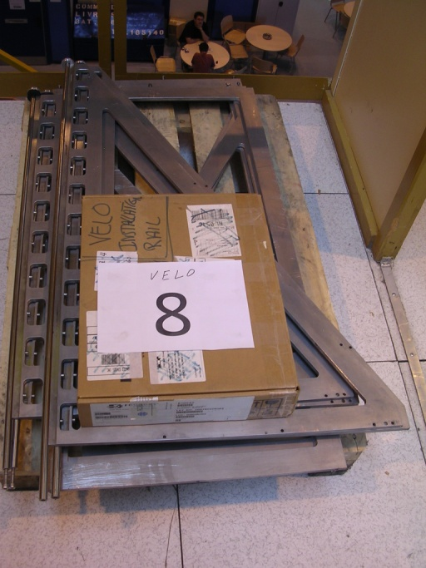
9 | 1 | Valve trolley |  |  | 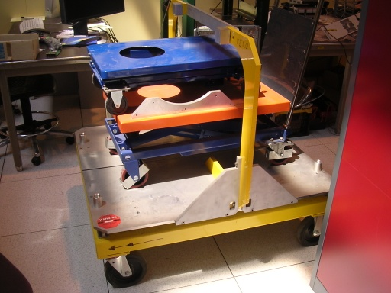
9 | 1 | Ion getter pump trolley
9 | 1 | Detector support trolley | http://www.nikhef.nl/pub/departments/mt/projects/lhcb-vertex/pdf/TVL-LIFTING_DEVICES/TRANSPORT_TROLLY_DET_SUPPORT/TVL19.pdf | 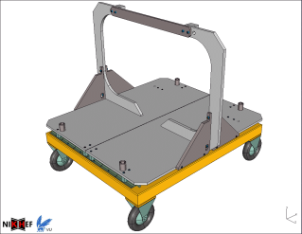
10 |  | Supper isolation material |  |  | 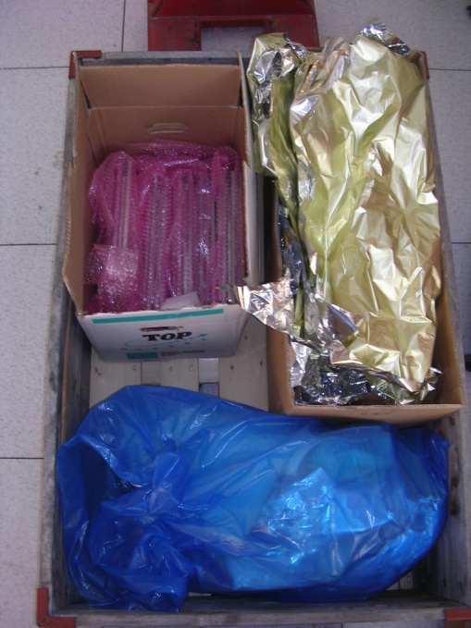
10 | 6 | Lifting hook: round 80 mm and M10 thread  Super-isolation | 11 rectangular blind flanges moved (on sept 2010) to Nikhef  Detector hood
11 | 1 | Tool trolley
12 | 1 | Detector Insert rail  19” cabinet parts | http://www.nikhef.nl/pub/departments/mt/projects/lhcb-vertex/pdf/TVL-LIFTING_DEVICES/DET_SUPPORTS/TVL0201.pdf |  | 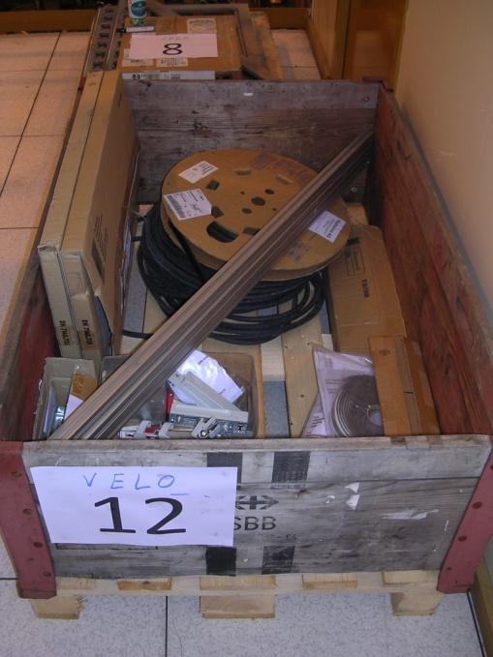
13 | 1 | 19” heating cabinet |  |  | 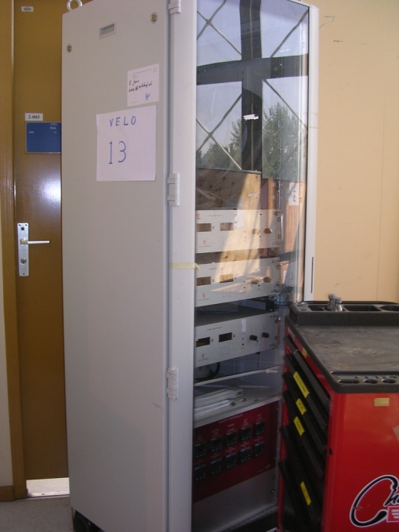
14 | 1 | Transport trolley elliptical head |  | 